CSC 340.03

Kayvaun Khoshkhou 920357344

Assignment 1

Due 09/01/2020 11:55 PM

Part A: Communication

1. iLearn

Screenshot of asmt 1 discussion forum response: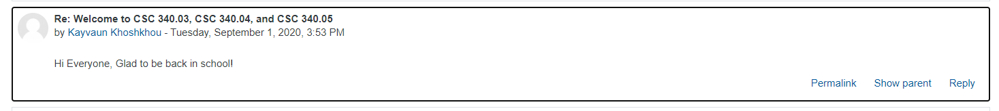

1. Emailing
   1. I confirm that I will use my SFSU email address (@mail.sfsu.edu) when contacting my grader and my course instructor so that my emails will not be filtered.
   2. When contacting my instructor I will start the email subject with format: “CSC340.04 TAC” so that I will get an answer timely.
   3. If I do not get an answer within 24 hours, I will check if I sent the email properly. In either case I will kindly resend my email message.
2. Grader
   1. <https://ilearn.sfsu.edu/ay2021/mod/forum/view.php?id=122349>
   2. Peijun Huang
   3. [Phuang5@mail.sfsu.edu](mailto:Phuang5@mail.sfsu.edu)
3. Guidelines for All Assignments and Assignment Report Template
   1. YES. This is to confirm that I have carefully read, understood, and agreed to the Guidelines for ALL Assignments above and the Assignment Report Template. I will strictly follow the instructions.
4. YES. This is to confirm that I have carefully read, understood, and agreed to the Course Policy on Student Conduct and Academic Honesty which was distributed to me with the course syllabus and whose digital copy was shared with me on the File Manager. I am acutely aware that the policy includes, but is not limited to, the San Francisco State University’s Code of Student Conduct (at https://conduct.sfsu.edu/standards), the Computer Science Department’s Student Policies (at https://cs.sfsu.edu/student-policies), and the Honor Code of this course (at http://csc220.ducta.net/00-README-StudentConduct_AcademicHonesty.pdf). I will strictly follow all the rules.

Top of Form

Part B: File Manager

Screenshot for transferable knowledge:

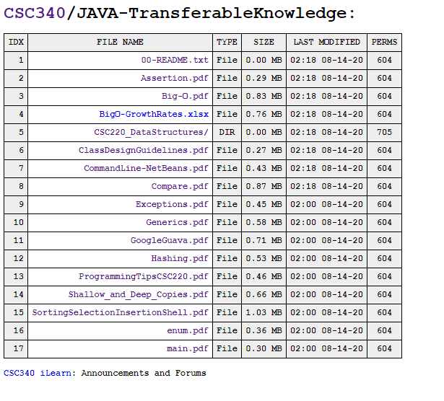Screenshot for CPP Reference:

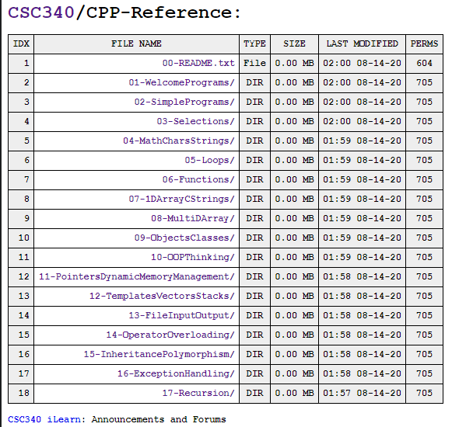

Part C: C++ IDE Installation

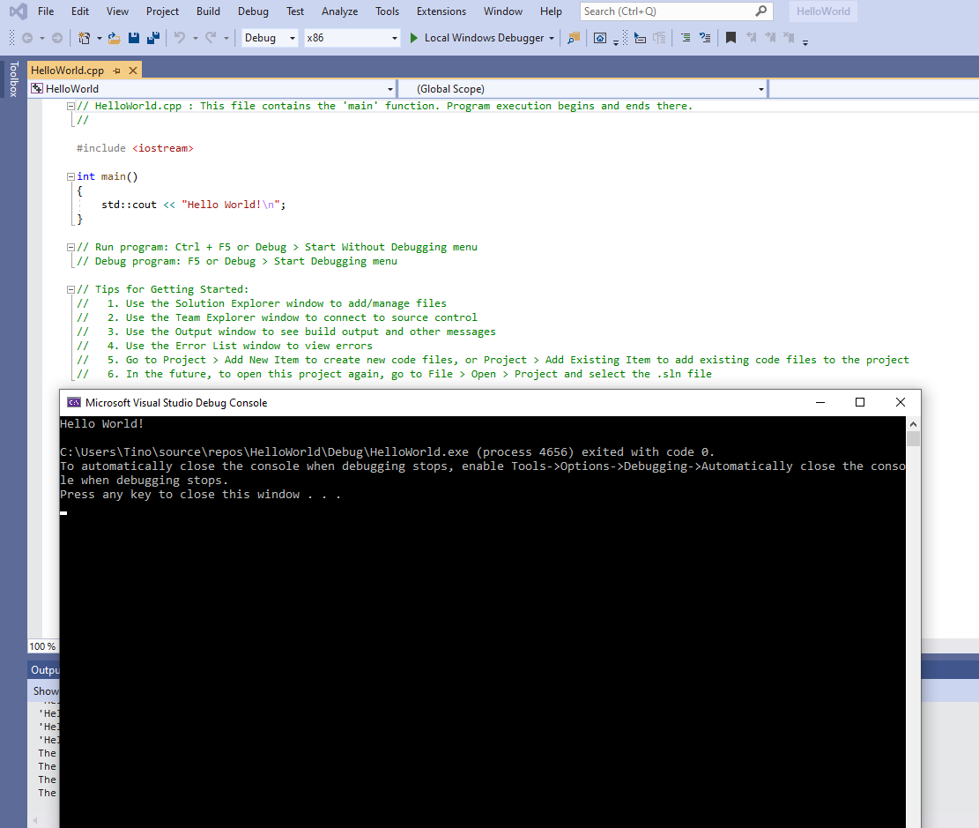

Part D: JAVA Refreshment 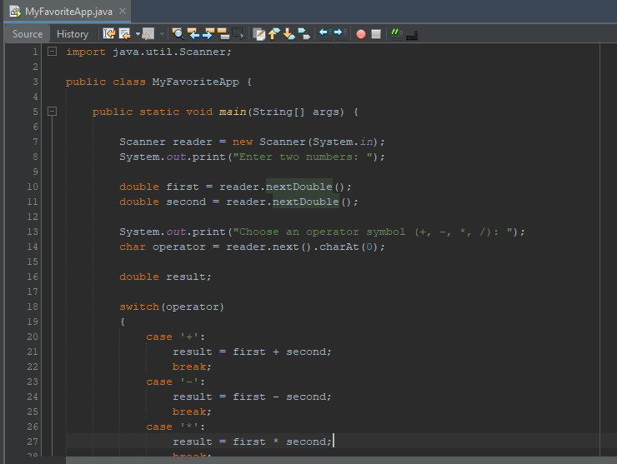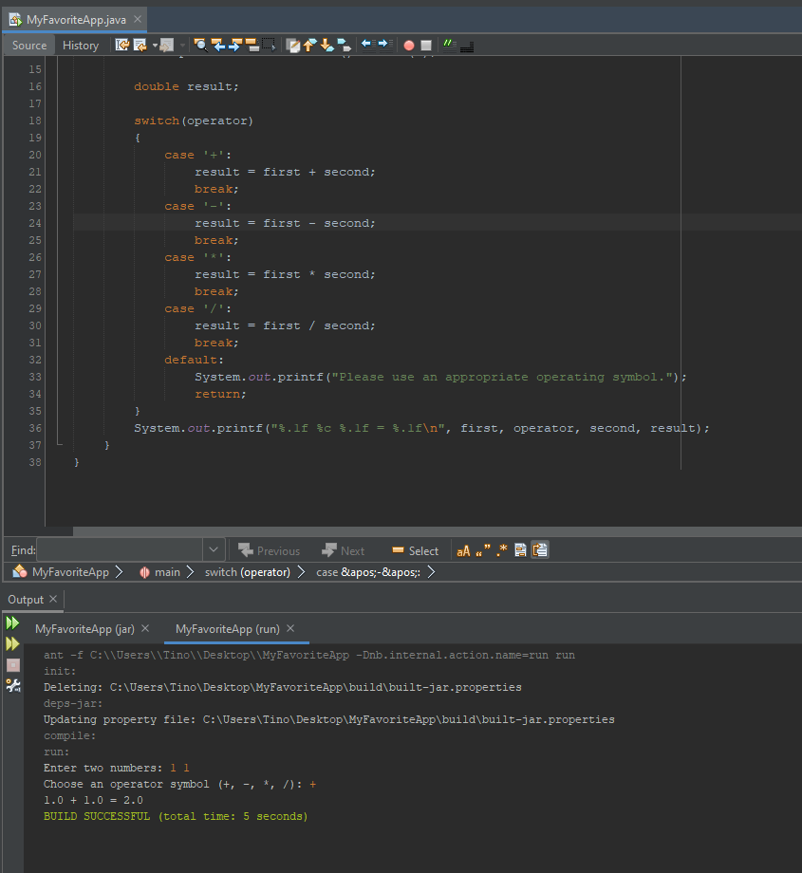

c) In order to improve my program I would incorporate a check for when there is no need for a double. I could do this by using System.out.printf() or System.out.format(). This would allow me to control the number of decimal spaces visible in the output. I would also expand on the number of operators to work with for example I would include modulus, or even exponents or square root.